Lab 1: DevSecOps Fundamentals & SDLC Security Integration
Cybersecurity Architecture, Design, and Secure Software Development

Task 1 — DevSecOps Pipeline Mapping
Introduction
For this task, I mapped security activities to the different stages of the software development process. The main idea of the pipeline is to include security throughout development instead of checking security only when the application is ready for release.
The pipeline starts with planning and continues through development, build, testing, release, deployment, and monitoring. Security checks are included at each stage, and information from monitoring can be used to improve future planning.
Pipeline Stages and Security Activities
Planning
Security considerations begin during the planning stage. Threat modeling and risk assessment can be used to identify possible threats before development starts.
This helps the team understand what needs to be protected and what security requirements should be considered.
Development
During development, programmers should follow secure coding practices. Code reviews can also help identify mistakes or security weaknesses before the code moves to the next stage.
Build
The build stage focuses on the software components used by the application. Dependency scanning and Software Composition Analysis (SCA) can help identify vulnerable third-party libraries or packages.
Testing
Security testing is performed using methods such as SAST and DAST.
SAST can be used to examine the application's source code, while DAST can test the application while it is running. These checks can help identify security issues before release.
Release
Before the application is released, a security gate can be used. Security requirements can be checked at this point, and serious issues can prevent the application from progressing until they are addressed.
Deployment
Security also needs to be considered when deploying the application. Secure configuration and proper secrets management help reduce the chance of exposing sensitive information.
Monitoring
After deployment, the application should continue to be monitored. Logs, SIEM systems, and alerts can help identify unusual activity or security-related events.
The information collected during monitoring can then be used as feedback for future planning and development.
CIA Principles
The pipeline also considers the three main security objectives:
- Confidentiality — protecting information from unauthorized access.
- Integrity — making sure information is not changed without authorization.
- Availability — making sure systems and information remain accessible when needed.
This shows that security is considered across the complete development lifecycle rather than being treated as a single activity.

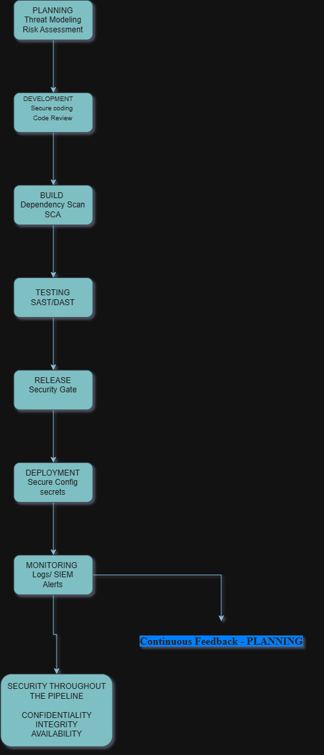

Task 2 — Secure Data Storage
Objective
For this task, I created a Python program to store user information in JSON format while applying basic security controls. The two main areas I focused on were protecting password information and checking whether stored records had been changed.
The implementation uses Fernet encryption for passwords and SHA-256 hashing for record-integrity checking.
Implementation
The program reads the user information and prepares each record before storing it.
The passwords are not saved as readable values. Instead, I used Fernet symmetric encryption to convert the password into an encrypted value before saving the record.
The encryption key is stored separately in a file named secret.key. It is not directly written inside the Python source code. This provides better separation between the application code and the key used for encryption.
Integrity Verification
I also added an integrity check to the records using SHA-256.
When a record is stored, the program generates a hash based on its contents. When the data is loaded again, the program calculates the hash for the record once more.
The two values are then compared. If they match, the record passes the integrity check. If they are different, it indicates that the contents of the record have been changed.
Execution Result
I tested the implementation with the supplied dataset. The execution output shows that five records were loaded successfully.
The program also reported that the passwords were encrypted using Fernet and that SHA-256 integrity values were generated. The subsequent verification showed that the records passed the integrity checks when the original data was unchanged.

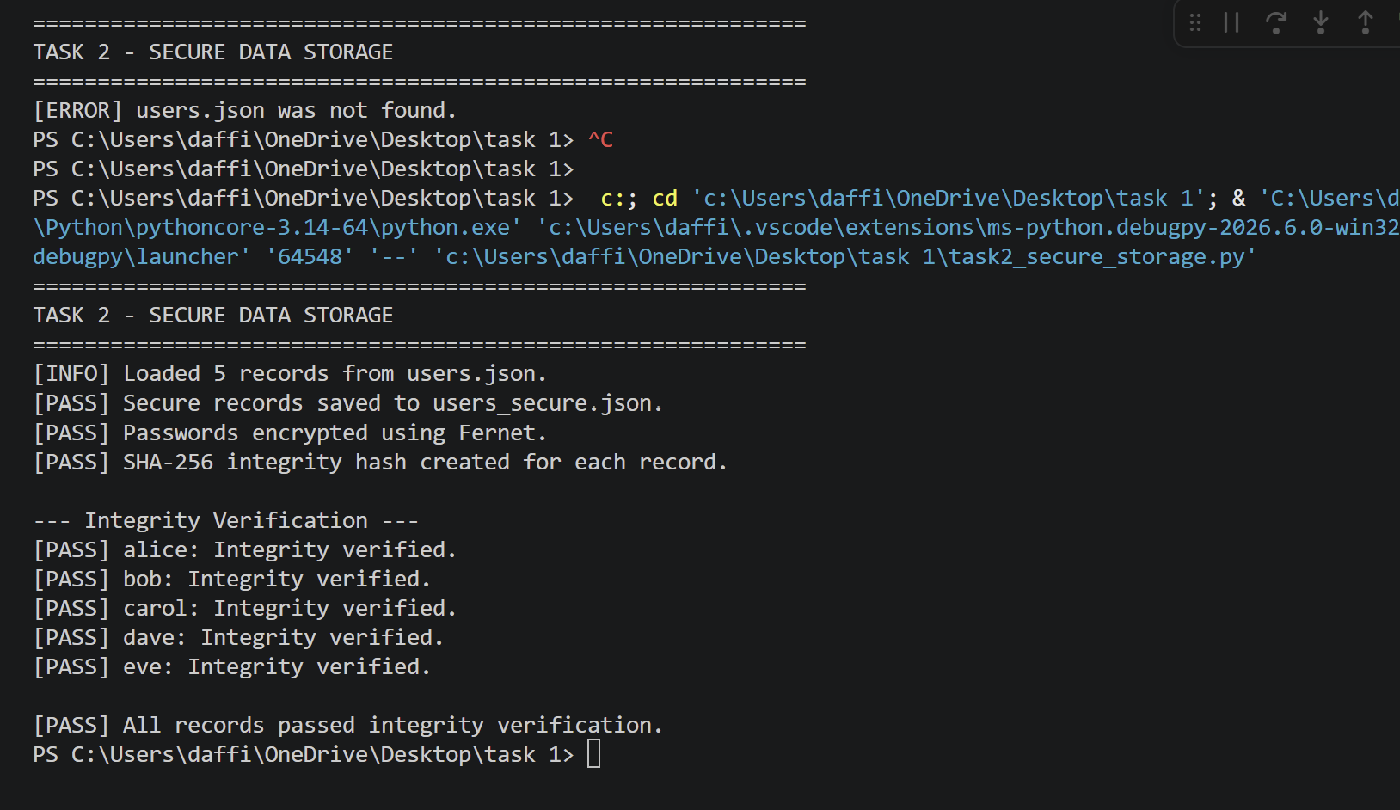
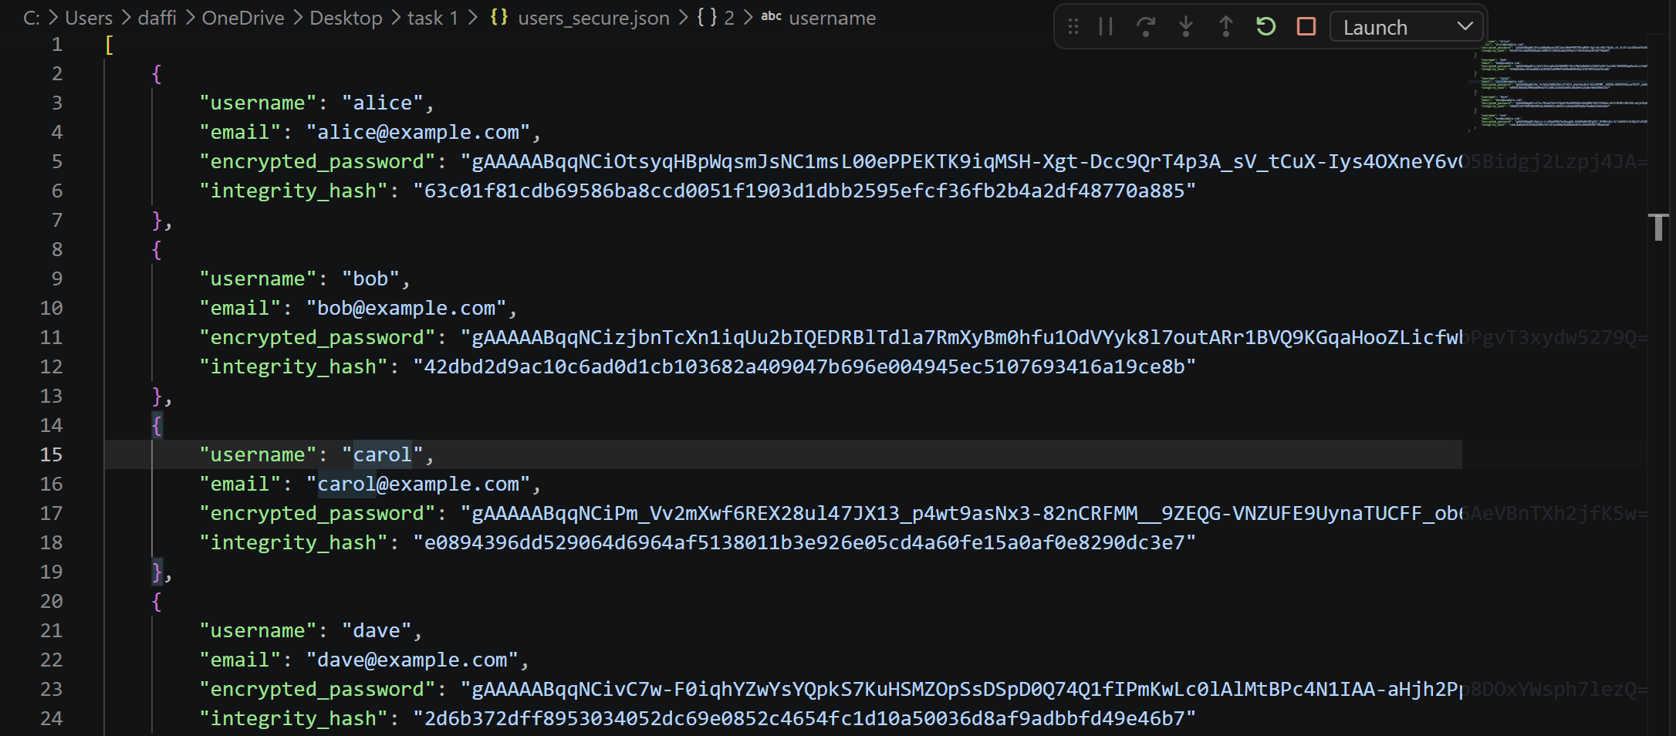

Task 3 — Threat Analysis
Introduction
After examining the DevSecOps pipeline and the secure data-storage program, I found a few security issues that could affect the application. Although encryption and integrity checks are already being used, some additional security measures are still required to reduce the overall risk.
1. Encryption Key Exposure
Risk
The security of the encrypted passwords depends on the encryption key. If an unauthorized person gets access to the secret.key file, they may be able to use the key to decrypt the protected password information.
This could result in sensitive information being exposed.
Mitigation
Access to secret.key should be limited to trusted users and application processes. The key should also be kept separate from the application source code. If this application were used in a real production environment, a dedicated secret management or key-management solution would provide better protection.
CIA Principle:
Confidentiality
2. Insufficient Input Validation
Risk
The program accepts information from users before adding it to the JSON file. If the entered data is not properly checked, incorrect or unexpected values could be stored.
For instance, a user might enter an invalid email address, leave a required field empty, or provide an unusually long value. These situations could affect the quality and reliability of the stored records.
Mitigation
Input should be checked before it is saved. The program should verify that mandatory fields contain values, apply suitable length restrictions, and check that information such as email addresses follows an acceptable format.
CIA Principle:
Integrity
3. Unauthorized Modification of Stored Data
Risk
The JSON file is used to hold the application's user records. If someone gains unauthorized permission to modify the file, they could change the information stored in one or more records.
Mitigation
The JSON file should only be writable by authorized users or application processes. Appropriate file permission should be applied to prevent unauthorized changes. In addition, the application should check the integrity of records whenever the data is loaded.
The SHA-256 comparison implemented in this lab helps identify whether the contents of a record have changed.
CIA Principle:
Integrity

Task 4 — Data Integrity Verification
Objective
The purpose of this task was to check whether any information had been changed between the original user dataset and the supplied tampered dataset.
I used SHA-256 hashes to compare the corresponding records in users.json and users_tampered.json. If the contents of a record change, its calculated hash value also changes, making the modification detectable.
Verification
The comparison successfully identified the Bob record as the modified record.
The original dataset contains:
Bob — BobSecure456
The tampered dataset contains:
Bob — BobHacked999
The password value is therefore different between the two datasets. Because the contents of the record changed, the SHA-256 hash calculated for that record also changed.
The program was able to identify Bob as the modified record during the comparison.
Execution Result
The execution evidence shows that:
- The original dataset contained five records.
- The tampered dataset contained five records.
- The program detected tampering.
- Bob was identified as the modified record.
- The integrity comparison completed successfully.
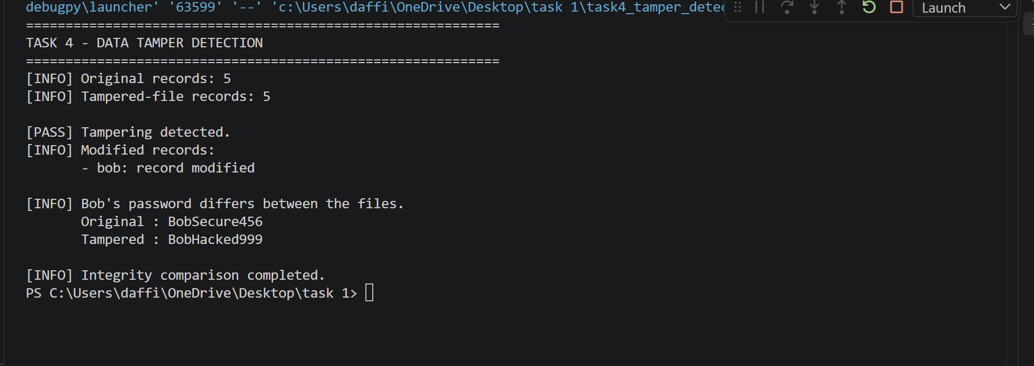
Security Recommendations:
1. Protect the Encryption Key
The secret.key file should be protected from unauthorized access. Only the application and authorized users should have permission to access the key. The key should not be placed directly inside the Python source code. For a production system, using a dedicated secrets or key-management service would provide stronger protection.
2. Improve Input Validation
All information entered by users should be checked before it is stored. The application should verify required fields, check appropriate formats for values such as email addresses, and place reasonable limits on the length of user input. This can help prevent invalid information from entering the dataset.
3. Restrict Access to Stored Files
The JSON files should only be accessible to users or processes that require them. Appropriate file permission should be applied so that unauthorized users cannot read or modify the stored records.
4. Continue Integrity Verification
The application should continue checking the integrity of records whenever the stored data is loaded. The SHA-256 mechanism used in this lab can help identify unexpected changes to records.
References
Sandu, A. K. (2021). DevSecOps: Integrating Security into the DevOps Lifecycle for Enhanced Resilience. Technology and Management Review, 6(1).
Used AI tools: Claude, draw.io

